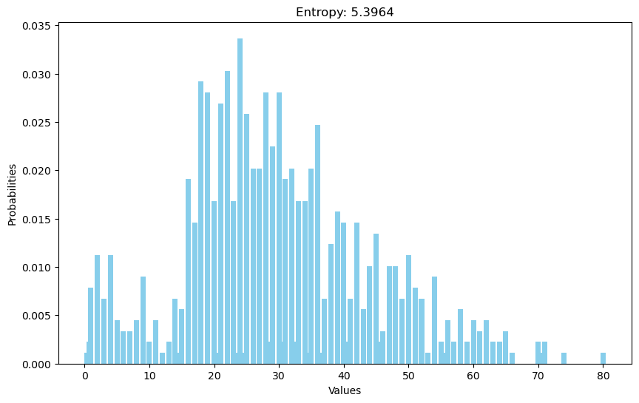

Entropy (‘Age’ column)

1. Use logistic regression to predict the survivors
2. Run diagnostics on my results

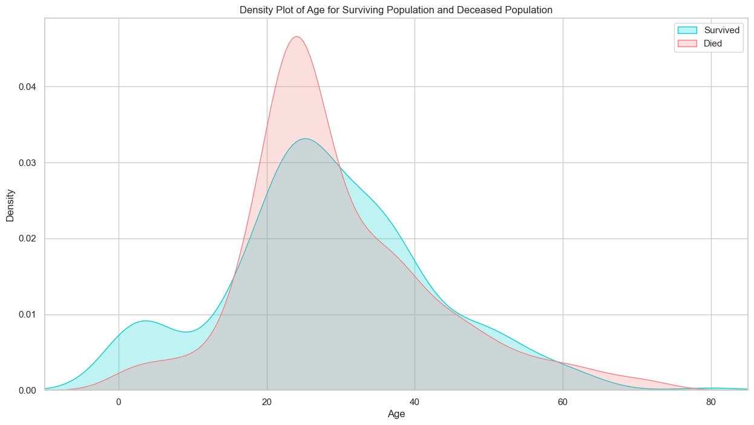

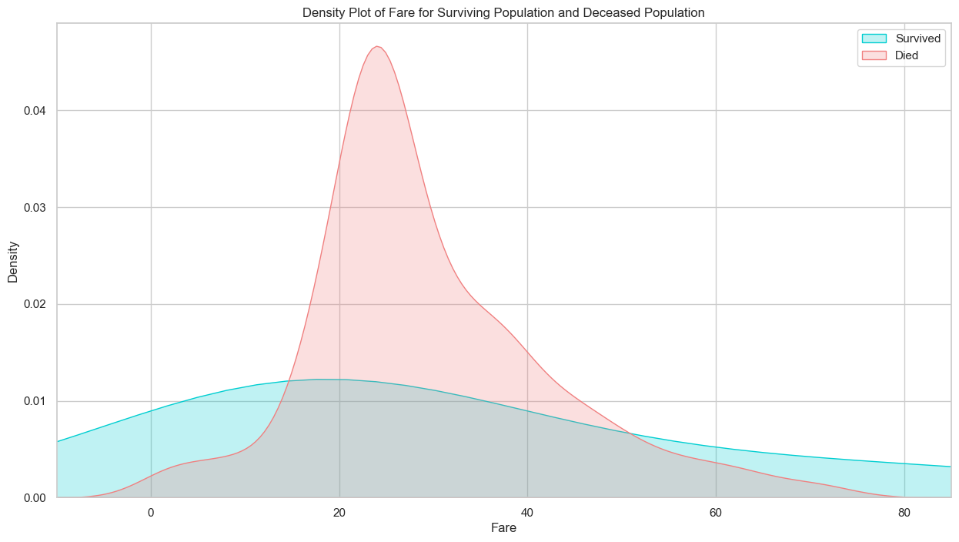

Decision tree (pruned and feature engineered)

Confusion matrix (decision tree)

Recall: 0.7134502923976608

Precision: 0.8052805280528053 (% of true positives that were correctly classified)

**Confusion matrix - support vector machine**

**Recall:  0.6812865497076024**

**Precision:  0.7420382165605095**

**(lower recall and precision)**

**Key takeaways: The support vector machine doesn’t do as great a job as the decision tree.**

**Confusion matrix: Logistic regression**

**Overall, logistic regression produces the most accurate results.**